IV International Scientific and Practical Conference “DIGITAL INTERNATIONAL RELATIONS 2025: People in the Focus of Digital Development”
Subconference “Artificial Intelligence in Strategic Communication of the BRICS Countries: Opportunities, Risks, Prospects”
Moscow, December 19, 2025

Venue: Assembly Hall, Diplomatic Academy of the Ministry of Foreign Affairs of Russia
The working language is English
Programme Committee
Prof. Darya BAZARKINA, Leading Researcher, Department of European Integration Studies, Institute of Europe of the Russian Academy of Sciences; Leading Researcher, School of International Relations, Saint Petersburg State University(Russia, Moscow and St. Petersburg).
Dr. Tianjiao JIANG, Associate Professor, Development Institute, Fudan University (China, Shanghai).
Prof. Konstantin PANTSEREV, Professor, Department of Theory and History of International Relations, Saint Petersburg State University, Saint Petersburg, Russia.
Prof. Evgeny PASHENTSEV, Chief Researcher, Institute of Contemporary International Studies, Diplomatic Academy of the Ministry of Foreign Affairs of Russia; Chief Researcher, School of International Relations, Saint Petersburg State University (Russia, Moscow and St. Petersburg) (Conference Program Committee Chair).

Subconference Programme (15:00-18:00)

15.00-15.10 OPENING CEREMONY

Prof. Evgeny PASHENTSEV, Chief Researcher, Institute of Contemporary International Studies, Diplomatic Academy of theMinistry of Foreign Affairs of Russia; Chief Researcher, School of International Relations, Saint Petersburg State University (Russia, Moscow and St. Petersburg), Conference Programme Committee Chair
SPEAKERS
Session 1. 15.10-17.10
Moderators
Prof. Evgeny PASHENTSEV, Prof. Darya BAZARKINA
Prof. Darya BAZARKINA, Leading Researcher, Department of European Integration Research, Institute of Europe of the Russian Academy of Sciences; Chief Researcher, School of International Relations, St. Petersburg State University (Russia, Moscow and St. Petersburg). Malicious Use of Artificial Intelligence in Political Struggles in Context of Strategic Communication
Mr. Atahualpa BLANCHET, Researcher at the Institute of Advanced Studies of the University of São Paulo and at the Center for Studies on Smart Cities, Pontifical Catholic University of São Paulo (PUC-SP) (Brazil, São Paulo). Smart Cities and AI in BRICS Countries: New Opportunities for Strategic Communication
Dr. Matthieu GRANDPIERRON, Associate Professor, ICES - Catholic Institute of Higher Studies (France, La Roche-sur-Yon); and Dr. Bogdana KOLJEVIC GRIFFITH, Senior Research Associate, Institute for Political Studies (Serbia, Belgrade). The Danger of Artificial Intelligence and Positivism to Understand Strategic Positioning
Dr. Adamkolo Mohammed IBRAHIM, Lecturer, Department of Mass Communication, Faculty of Communication and Media Studies, University of Maiduguri; Member, Association of Media and Communication Researchers of Nigeria (Nigeria, Maiduguri). Artificial Intelligence and Strategic Communication in BRICS: Responsible Tools, Strategic Risks, and Pathways to Synchronised Practice
Dr. Tianjiao JIANG, Associate Professor, Development Institute, Fudan University (China, Shanghai). Drivers, Foundations, and Challenges of BRICS Cooperation on Artificial Intelligence
Dr. Natalia KIREEVA, Associate Professor (Entrepreneurship and Logistics), Plekhanov Russian University of Economics (Russia, Moscow). Use of Artificial Intelligence in Scientific Work in BRICS Countries: Opportunities and Challenges for Strategic Communication
Dr. Ping LANG, Head and Senior Fellow, Division of Security Studies, Institute of World Economics and Politics, Chinese Academy of Social Sciences (China, Beijing). Approaches to Understanding AI risks: An Interdisciplinary Perspective
Dr. Zheng LIANG, Professor of the School of Public Policy and Management; Research Fellow and Vice President of Institute for AI International Governance (I-AIIG); Director of the Research Center on AI Governance; Research Fellow and Deputy Director of China Institute for Science &Technology Policy (CISTP), Tsinghua University (China, Beijing). AI Cooperation Among BRICS Countries
Prof. Artwell NHEMACHENA, Full Professor of Sociology and Anthropology, University of Namibia (Namibia, Windhoek); Research Fellow at the University of South Africa and at the Universiti Sultan Zainal Abidin (Malaysia). BRICS Strategic Communication in the Age of Artificial Intelligence Singularity
Prof. Konstantin PANTSEREV, Chief Researcher, School of International Relations, St. Petersburg State University (Russia, St. Petersburg). Artificial Intelligence in Indonesia's Strategic Communications: Opportunities, Risks, and Prospect
Q&A

BREAK 17.10 – 17.20

Session 2. 17.20 – 19.00
Moderators
Prof. Evgeny PASHENTSEV, Prof. Konstantin PANTSEREV
Prof. Evgeny PASHENTSEV, Chief Researcher, Institute of Contemporary International Studies, Diplomatic Academy of the Ministry of Foreign Affairs of Russia; Chief Researcher, Saint Petersburg State University (Russia, Moscow and St. Petersburg). Possibilities of Synergistic Effect of Multifactorial AI Impact on BRICS Countries in the Short and Medium term
Mr. Bryan Leonardo PATARROYO, Master's student of the program “International Relations (Artificial Intelligence and International Security)”, St. Petersburg State University (Russia, St. Petersburg). Malicious Use of Artificial Intelligence and Challenges of Information and Psychological Security in the Colombian Economy
Dr. Sergio Ricardo de Melo QUEIROZ, Researcher, Institute for Applied Economic Research (IPEA) (Brazil, Brasilia), and Dr. Denise do Carmo DIREITO, Researcher, Institute for Applied Economic Research (IPEA) (Brazil, Brasilia). Toward a Sovereign BRICS AI Stack: Open-Source Infrastructure as a Foundation for Strategic Communication
Ms. Elizaveta SAFONKINA, Senior Researcher, School of International Relations, Saint Petersburg State University (Russia, Moscow and St. Petersburg). Strategic Communication of BRICS Capital Cities with Local Communities: AI Integration into Life∗
Dr. Sergey SEBEKIN, Senior Research Fellow, School of International Relations, St. Petersburg State University; (Russia, Irkutsk and St. Petersburg). BRICS Strategic Communications in the Era of Artificial Intelligence and Infocracy: the Risks of Replacing Inclusive Communication with Synthetic Information Flows∗
Dr. Elena TRUFANOVA, Associate Professor, Leading Research Fellow, Institute of Philosophy of the Russian Academy of Sciences; Professor, State Academic University for the Humanities (Russia, Moscow). Algorithmic Bias as a Risk Factor: National AI Models in BRICS Strategic Communications
Dr. Marius VACARELU, Lecturer, National School of Political and Administrative Studies (Romania, Bucharest). The Risks of Big Tech for Strategic Communication of EU and BRICS: Legal Aspects
Dr. Anastasia ZABELLA, Senior Researcher, School of International Relations, St. Petersburg State University (Russia, Moscow and St. Petersburg). Artificial Intelligence: The Chinese Experience and Its Implications for the BRICS+ Countries∗
Q&A
Conclusion 19.10 – 19.15

SUBCONFERENCE PARTICIPANTS
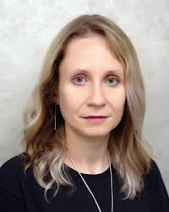
Prof. Darya BAZARKINA is a Leading Researcher at the Department of European Integration Research of the Institute of Europe of the Russian Academy of Sciences; Chief Researcher at the School of International Relations, Saint Petersburg State University (Russia, Moscow and St. Petersburg). Research Coordinator of Communication Management and Strategic Communication at the International Center for Social and Political Studies and Consulting (ICSPSC). Member of the International Experts’ Network “European Union – Russia – Communication Management” (EURUCM). Member of the International Research Group on Threats for International Psychological Security by Malicious Use of Artificial Intelligence (Research MUAI). Author of more than 130 publications on communication aspects of terrorism and counter-terrorism as well as the problems of hybrid threats, malicious use of artificial intelligence and psychological security, published in Russian, English, Italian, Serbian, and Vietnamese.).

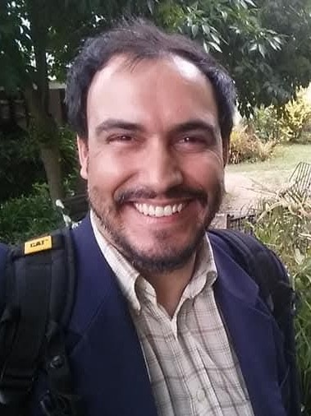
Mr. Atahualpa BLANCHET is a researcher at the Institute of Advanced Studies at the University of São Paulo and a member of the Artificial Intelligence Rapporteurship of the Brazilian National Human Rights Council (Brazil, São Paulo). He is also part of the Center for Studies on Smart Cities at PUC-SP and previously served as an Artificial Intelligence technical expert at the UNESCO Office for Latin America and the Caribbean. He is a columnist for the official website of the BRICS Presidency in 2025 and contributed as a columnist for the G20 in 2024 on issues related to emerging technologies. He is the author of the book Artificial Intelligence and the Future of Work in Transformation, published in October 2025.

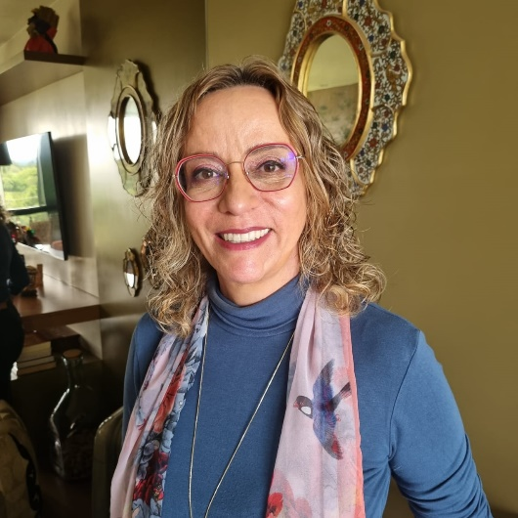
Dr. Denise DIREITO holds a Ph.D. in Political Science from the University of Brasília (UnB-Brazil), with a doctoral research period at the Université de Versailles Saint-Quentin-en-Yvelines (UVSQ-France). Since 2002, she is a public servant and member of the federal career of Specialists in Public Policy and Government Management. Currently, she works as a researcher at the Institute for Applied Economic Research (IPEA) (Brazil, Brasilia). Her main research interests are social policy governance and the digital transformation of the State.

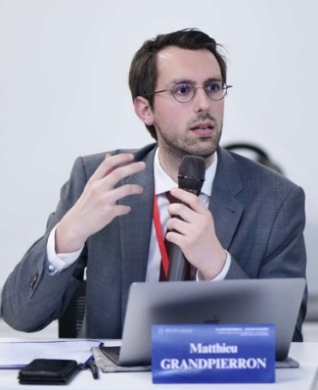
Dr. Matthieu GRANDPIERRON is Associate Professor of international relations and head of the political science department at ICES - Catholic Institute of Higher Studies (France, La Roche-sur-Yon). He is also Senior Researcher at Ecole Polytechnique (Paris) and Visiting Professor at Tsinghua University and at the Shanghai University of Political Science and Law. His book, Nostalgic Virility: How Leaders of Great Powers Cope with Status Decline (McGill Queens, 2024) employed MMCDA to analyse over 1000 declassified documents from French, American and British archives (as well as Russian and Chinese official government documents) to investigate the role that status considerations and nostalgic virility can play in great powers’ decisions to go to war. He was also co-convener of BISA’s ‘International Relations as Social Sciences’ working group and an invited Research Fellow at the University of Ottawa from 2018 to 2019 and also spent 2019-2020 on a research scholarship by Columbia University (CES-Alliance mobility program). His current research investigates how international law and the international order are understood and described by Chinese, Russian and Iranian officials and what alternatives they propose. This research is conducted under the framework of mixed methods critical discourse analysis. He has two forthcoming books: a research method book and a book comparing BRICS+ countries approaches to global issues, both for Palgrave Macmillan. In addition, he has published more than a dozen of peer-reviewed articles and book chapters.

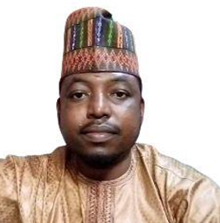
Dr. Adamkolo Mohammed IBRAHIM, PhD, is a Lecturer in the Department of Mass Communication at University of Maiduguri (Nigeria, Maiduguri). His academic and professional expertise spans mass communication and journalism, development communication, including strategic communication, social media research, social television, computer-mediated communication, human-computer interaction, cybersecurity and ICT adoption. He participated in the October 31st, 2025 international conference of BRICS Strategic Communication in Global Governance. Dr. Adamkolo has published widely in peer-reviewed journals, book chapters and contributed to interdisciplinary research projects addressing communication, governance and technological innovation in Africa and beyond. He also serves as a blind peer reviewer and copyeditor for international and local journals, drawing on his experience in academic publishing and knowledge dissemination. His current research examines the intersection of generative artificial intelligence, diplomacy and multilateral governance, with a particular focus on BRICS strategic communication. He has received recognition for his scholarly contributions and is actively engaged in mentoring early-career researchers and journalists.


Dr. Tianjiao JIANG is Associate professor at Development Institute, Fudan University (China, Shanghai). He also serves as associate director of Center for BRICS Studies at Fudan University and research fellow of Center for Global AI Innovative Governance. His research focuses on emerging technologies and international security. He has published 3 books and 40 academic papers in the Journal of Chinese Political Science, Asian Perspective, Chinese Political Science Review, Copenhagen Journal of Asian Studies, and edited volumes by SIPRI and USIP. Dr. Jiang is ACONA fellow (2021-2022) of Harvard University’s Davis Center for Russian and Eurasian Studies, CTBTO Youth Group and Center for Energy and Security Studies fellow (2021-2022), NPIHP fellow of Woodrow Wilson International Center for Scholars (2016), and visiting scholar at George Washington University (2017).

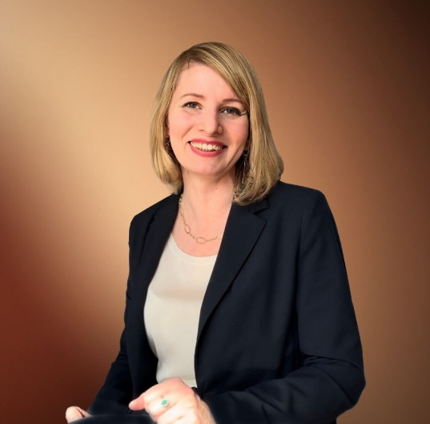
Dr. Natalia KIREEVA, PhD in Economics, is Associate Professor (Entrepreneurship and Logistics) at the Plekhanov Russian University of Economics (Russia, Moscow); founder of the educational project “Constructor of Scientific Career”; author of more than 100 scientific publications, textbooks and monographs, including papers indexed in Scopus and Web of Science; Hirsch index: 14. Developer of programmes on research methodology and a science popularizer with a Telegram blog followed by over 20,000 subscribers. Research interests include the application of AI in science and business, as well as in intercultural and cross-industry communication.


Dr. Bogdana KOLJEVIĆ GRIFFITH (PhD New School for Social Research, New York, 2010) is Senior Research Associate at the Institute for Political Studies (Serbia, Belgrade). As an Associate Professor she currently also teaches at ICES - Catholic Institute of Higher Studies (France, La Roche-sur-Yon). Koljević Griffith is Senator of the Republic of Srpska, external Foreign Policy Advisor to the President of Republic of Srpska in Banja Luka and Member of Parliament in the National Assembly of the Republic of Serbia. Bogdana Koljević Griffith is the author of eight monographs and over seventy articles in the fields of biopolitics, democracy, contemporary political philosophy and political theory with the special focus on rethinking contemporary Europe. Her works have been published in Serbian, Russian, English, French, Italian and Portuguese.


Dr. Ping LANG is Head and Senior Fellow, Division of Security Studies, Institute of World Economics and Politics, Chinese Academy of Social Sciences (China, Beijing). Research interests: global cyber governance. Her research areas include national security in the digital age, international governance of cyberspace. She is also senior research fellow at the National Institute for Global Strategy of Chinese Academy of Social Sciences, council member of the Emerging Economies Research Association, former member of the Cybersecurity Committee of the Global Future Council of the World Economic Forum, member of the Advisory Committee of the China Internet Governance Forum, member of the Cybersecurity Legal Advisory Committee of the Ministry of Public Security, and invited professor at the Cyber Governance Research Center at Fudan University. She has published some books and dozens of academic papers, including Book Cyberspace International Governance and Major Country Games, articles “Global AI governance, Challenges and Role of China”, “Global AI Governance and Major Country Games”, etc. She has also participated in many international conferences and 1.5 and second-track dialogues.

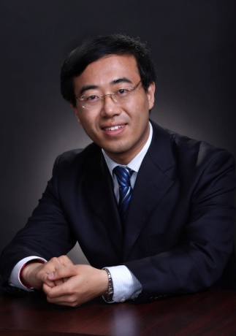
Dr. Zheng LIANG now serves as the Professor of the School of Public Policy and Management, Tsinghua University, as well as the research fellow and vice president of Institute for AI International Governance, Tsinghua University (I-AIIG), the director of the Research Center on AI governance at Tsinghua, the research fellow and deputy director of China Institute for Science &Technology Policy at Tsinghua University (CISTP).
Dr. Liang got his doctor’s degree of economics at Nankai University (2003) and accomplished the senior executive training program on leadership at Kennedy School of Government, Harvard University (2010). He had visited at MIT Industrial Performance Center (MIT IPC) as the Fulbright Visiting Research Scholar for one year (2012).
The main areas of his research now focus on Science, Technology and Innovation Policy, Globalization of R&D, IPRs and Standardization, Emerging Technology and Innovation Governance etc. Besides academic publishing on peer review journals such as National Science Review, Regional Studies, Journal of Informetrics, Industry and Corporate Change, World Economy etc. Dr. Liang also participated in some important research projects such as the Strategic Research for National Medium and Long Term Science and Technology Development Program (MLP) of China. He used to be the member of National Innovation Survey Expert Group (2014-2017), as well as the member of Sino-US Innovation Dialogue Expert Group (2015-2018).

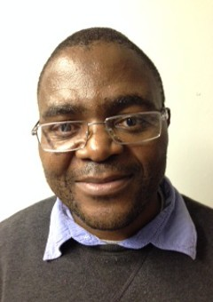
Prof. Artwell NHEMACHENA is a Full Professor of Sociology and Anthropology at the University of Namibia (Namibia, Windhoek). He is also a Research Fellow at the University of South Africa and at the Universiti Sultan Zainal Abidin in Malaysia in 2025. He holds a PhD in Social Anthropology. He has published over 20 books and over 100 book chapters and journal articles in the areas of security, environment, development, food security and food sovereignty, futurology, sociology of anticipation, anthropology of anticipation, sociology of industry and work organisations, violence and conflict, pandemics and society, sociology and social anthropology of science and technology studies, relational ontologies, indigenous knowledge systems and decoloniality. He has been a member of the Council for the Development of Social Science Research in Africa (CODESRIA) between 2010 and 2018. He is an editorial board member for several internationally renowned journals; and he has reviewed applications for funding of anthropological research in a number of international organisations. He has given numerous presentations and lectures around the world. Recently, he was part of experts advising the World Health Organization on Dual-Use Research.

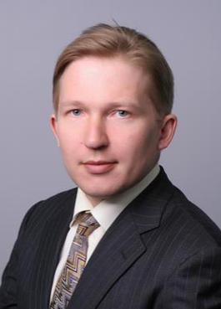
Prof. Konstantin PANTSEREV is Professor at the Department of the Theory and the History of International Relations and Chief Researcher of the School of International Relations, Saint Petersburg State University (Russia, St. Petersburg). Member of the Scientific Council of the Russian Academy of Sciences on the problems of economic, socio-political and cultural development of African countries. The author of over 90 research articles, author and co-author of 8 books. Member of the International Research Group on Threats for International Psychological Security by Malicious Use of Artificial Intelligence (Research MUAI). Research Interests: problems of ensuring international information security, information and psychological warfare, the use of machine learning in political analysis, natural language processing, malicious use of AI, strategic communication, socio-economic development of sub-Saharan Africa, problems of ensuring technological sovereignty. Participant of the grant project ‘BRICS Strategic Communication in Global Governance’, supported by the Russian Science Foundation, № 25-18-00699, https://rscf.ru/project/25-18-00699/ (2025-2027).

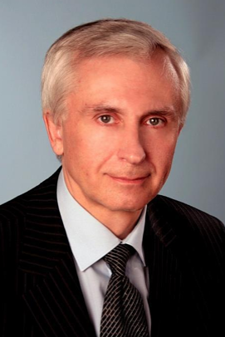
Prof. Evgeny PASHENTSEV is Professor, Chief Researcher of Diplomatic Academy of the Ministry of Foreign Affairs of Russia; Chief Researcher of the School of International Relations, St. Petersburg State University (Russia, Moscow and St. Petersburg). Coordinator of the International Research Group on Threats for International Psychological Security by Malicious Use of Artificial Intelligence (Research MUAI); Affiliate Member of the Global Strategic Communication Consortium; Member of the International Advisory Board of “Comunicar,” (WoS, Scopus Q1, UK) and the “Journal of Political Marketing.” (Scopus Q1, USA). The author of 14 books, and more than 250 articles and chapters in collective monographs published in Russian, English, Spanish, Chinese, and other languages. Areas of current research: malicious use of AI and international psychological security, international security in the context of creation of general and strong AI, BRICS strategic communication in global governance, the risks of military coups and/or civil wars under conditions of social instability. Head of the grant project ‘BRICS Strategic Communication in Global Governance’, supported by the Russian Science Foundation, № 25-18-00699, https://rscf.ru/project/25-18-00699/ (2025-2027).

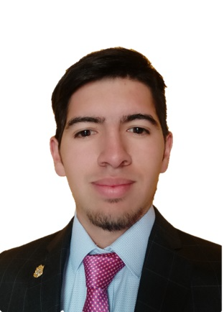
Mr. Brayan Leonardo PATARROYO Garzon is Master's student of the program "International Relations (Artificial Intelligence and International Security)", St. Petersburg State University (Russia, St. Petersburg). He holds two Bachelor's degrees from the University of Rosario (Colombia), majoring in International Business Management and Logistics and Production Management. His professional experience includes positions in private companies, such as Director of Foreign Trade, as well as at the Bogota Chamber of Commerce as a specialist in the Macro Sector of Business Services and IT, with special support for the IT, financial services, logistics and mobility sectors. At the same time, he was engaged in teaching at the University of Rosario. His main academic interests focus on the impact of artificial intelligence on international security and business internationalization strategies.

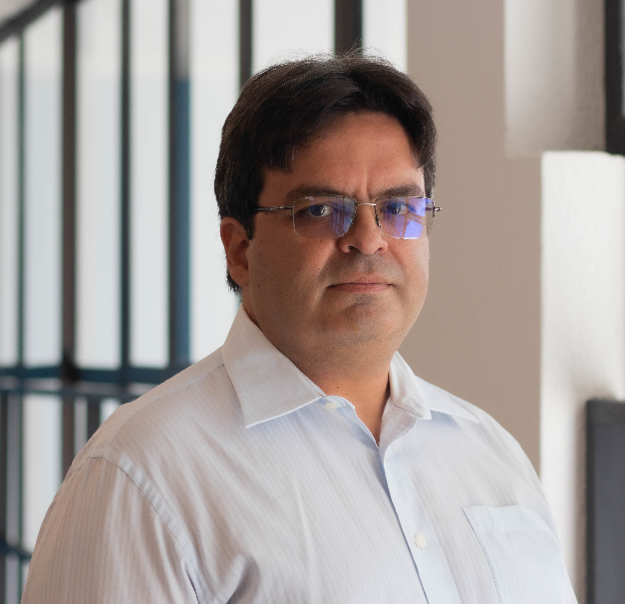
Dr. Sergio Ricardo de Melo QUEIROZ earned his Ph.D. in Computer Science from Sorbonne University (Université Pierre et Marie Curie) in 2008. He is currently a Digital Transformation Researcher at the Institute for Applied Economic Research (Ipea) (Brazil, Brasilia), a public institution under Brazil’s Ministry of Planning and Budget, where he serves as a Planning and Research Analyst. Previously, he was an Associate Professor at the Center for Informatics (CIn) at UFPE, one of Brazil’s leading computer science research centers. His research focuses on artificial intelligence, particularly multi-criteria decision support, machine learning, clustering, recommender systems, and symbolic data analysis.

Ms. Elizaveta SAFONKINA is Senior Researcher of the School of International Relations at the Saint Petersburg State University; Head of Division on International Rankings of Sustainable Urban Development and International Cooperation Department at the Moscow Analytical Center and Leading Specialist of Department of Scientometrics and Ranking Promotion at the Russian Academy of National Economy and Public Administration (RANEPA) (Russia, Moscow and St. Petersburg). She authored 14 articles published in the journals indexed in Scopus and Web of Science, devoted to regional and global governance, G20, BRICS, sustainable development, SDGs and business-state relations. Participant of the grant project ‘BRICS Strategic Communication in Global Governance’, supported by the Russian Science Foundation, № 25-1800699, https://rscf.ru/project/25-18-00699/ (2025-2027).

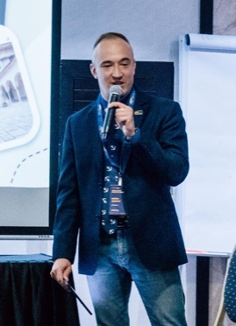
Dr. Sergey SEBEKIN is Associate Professor at the Department of Political Science, History and Regional Studies of Irkutsk State University. Senior Researcher at the School of International Relations, Saint Petersburg State University (Russia, Irkutsk and St. Petersburg). Author of more than 50 scientific articles, analytical notes, and reports on various issues of international cybersecurity and the malicious use of artificial intelligence. Oxford Russia Foundation Fellow 2014-2015. Member of the International Research Group on Threats for International Psychological Security by Malicious Use of Artificial Intelligence (Research MUAI). Research interests: artificial intelligence and world politics; the impact of artificial intelligence on international security; metaverses; problems of international cybersecurity; strategic stability and cyber weapons; national concepts and strategies of cybersecurity; theories of cyber warfare; the doctrine of cyber deterrence; the applicability of international law to the "digital age". Participant of the grant project ‘BRICS Strategic Communication in Global Governance’, supported by the Russian Science Foundation, № 25-1800699, https://rscf.ru/project/25-18-00699/ (2025-2027).

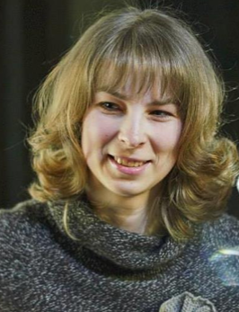
Dr. Elena TRUFANOVA is DSc in Philosophy, Associate Professor, Leading Research Fellow, Department of the Theory of Knowledge, RAS Institute of Philosophy (Russia, Moscow). Professor at the State Academic University for the Humanities, theory of knowledge and philosophy of cognitive research expert. Executive Editor of the Journal "Philosophy of Science and Technology". Author of more than 100 papers and monographs, including the series of papers dedicated to the transformations of human and society under the influence of digitalization. Main research interests include the Self, personal identity, theory constructionism, of knowledge, constructivism, social realism, relativism, philosophy of information, philosophy of technology, escapism.

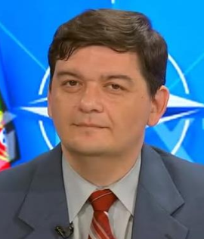
Dr. Marius VACARELU holds a PhD and is a researcher in political sciences and a legal expert (Romania, Bucharest). He graduated from the Law Faculty in Bucharest. Marius Vacarelu teaches public law in the National School of Political Science and Public Administration since 2005, he is a member of the committee, which edits the Romanian magazine GeoPolitica, and is a head of "The Geopolitics of the East Association" which runs the website www.geopoliticaestului.ro. Marius Vacarelu is a member of the International Research Group on Threats to International Psychological Security through Malicious Use of Artificial Intelligence (Research MUAI). He is an author/coauthor/coordinator of 25 books and more than 250 academic articles including the articles/book chapters on the role of AI in international relations and political processes published in Romania, Russia, UK, US and othe countries. Marius Vacarelu is a frequent speaker on Romanian television on geopolitics issues. He is a blogger for Romania’s most important journal Adevarul. Marius has presented papers and published articles in Russia, Czech Republic, France, Poland, UK and the US.


Dr. Anastasia ZABELLA is Associate Professor of the Department of Theory and History of International Relations of Peoples' Friendship University of Russia (RUDN University); Senior Researcher at the School of International Relations, Saint Petersburg State University; Senior Lecturer of the Department of the Foreign Languages of Peoples' Friendship University of Russia (RUDN University), assistant professor of the Department of the Foreign Languages of the Odintsovo Branch of MGIMO University (Russia, Moscow and St. Petersburg). Author and co-author of 5 monographs and more than 35 publications on China’s foreign policy, China-Africa relations, China Arctic Policy, Central Asia in Russian and Chinese Foreign Policy, “One Belt One Road” etc., published in Russian, English, Chinese. Participant of the grant project ‘BRICS Strategic Communication in Global Governance’, supported by the Russian Science Foundation, № 25-18-00699, https://rscf.ru/project/25-18-00699/ (2025-2027).

The research was supported by a grant № 25-18-00699 from the Russian Science Foundation, https://rscf.ru/en/project/25-18-00699/. -00699 from the Russian Science Foundation, https://rscf.ru/en/project/25-18-00699/
∗ The research was supported by a grant № 25-18-00699 from the Russian Science Foundation, https://rscf.ru/en/project/25-18-00699/. The research was supported by a grant № 25-18-00699 from the Russian
∗ The research was supported by a grant № 25-18-00699 from the Russian Science Foundation, https://rscf.ru/en/project/25-18-00699/. /
∗ The research was supported by a grant № 25-18-00699 from the Russian Science Foundation, https://rscf.ru/en/project/25-18-00699/. search was supported by a grant № 25-18-00699 from the Russian Science Foundation, https://rscf.ru/en/project/25-18-00699/

